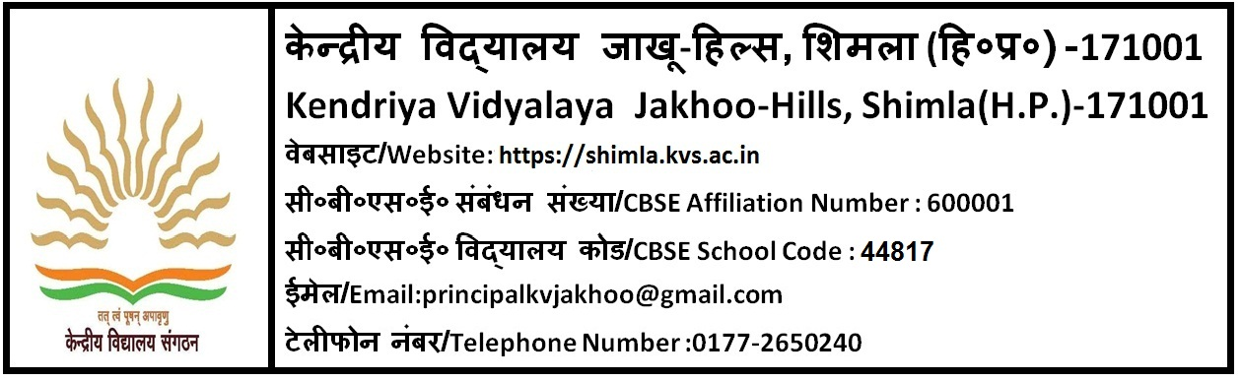
पूर्णत: अंशकालीन/ संविदा शिक्षक
केन्द्रीय विद्यालय जाखू में पूर्णत: अंशकालीन/ संविदा आधार पर वर्ष 2022-23 के लिए नियुक्ति हेतु शिक्षकों का पैनल बनाया जाना है, साक्षात्कार में उपस्थित होने के लिए इच्छुक उम्मीदवार योग्यता व नियमो हेतु www.kvsangathan.nic.in के अनुरूप आवेदन पत्र विद्यालय की वेबसाइट https://shimla.kvs.ac.in/ से प्राप्त करें, तथा 29 -03-2022 को प्रात 9 :00 बजे से 9:30 बजे के बीच संबन्धित विषयों के भरे हुए फॉर्म पंजीकरण के लिए केवी जतोग में तथा 30.03.2022 को संबन्धित विषयों के फार्म केवी जाखू में जमा करवाएँ , 9:30 बजे के बाद फ़ार्म जमा (पंजीकरण ) नहीं होगा।
नोट : पी.जी .टी (हिंदी, अंग्रेजी,गणित, भौतिक विज्ञान, रसायन विज्ञान, जीव विज्ञान,वाणिज्य,अर्थशास्त्र,भूगोल,इतिहास,राजनीति विज्ञान, जैव प्रोद्योगिकी) और टी. जी. टी (हिंदी,अंग्रेजी ,गणित, संस्कृत,सामाजिक विज्ञान एवम् विज्ञान) के फॉर्म 30.03.2022 को के. वि. जाखू के कार्यालय में जमा होंगे तथा वहीं उनका साक्षात्कार होगा। पी. जी. टी कंप्यूटर विज्ञान, प्राथमिक शिक्षक, नर्स, काउंसलर, स्पोर्ट्स कोच, योग शिक्षक और कंप्यूटर अनुदेशक के फॉर्म के. वि. जतोग के कार्यालय में जमा होंगे तथा इनका साक्षात्कार 29 -03-2022 को केवि जतोग में होगा।

क्र. | पद का नाम | विषय | अनिवार्य योग्यता
1. | पी.जी .टी | हिंदी, अंग्रेजी, गणित, भौतिक विज्ञान, रसायन विज्ञान,जीव विज्ञान, वाणिज्य, अर्थशास्त्र, भूगोल, इतिहास और  राजनीति विज्ञान, जैव प्रोद्योगिकी | Essential Qualification  1. Two years’ Integrated Post Graduate M.Sc Course of Regional College of Education of NCERT in the concerned subject;  Or  Master Degree from a recognized University with at least 50%marks in aggregate in the following subjects:  a) PGT (English)- English  b)PGT (Hindi) – Hindi or Sanskrit with Hindi as one of the subjects at Graduate level.  c) PGT (Maths) Mathematics/ Applied Mathematics  d) PGT (Physics)–Physics / Electronics/Applied Physics/Nuclear Physics.  e) PGT (Chemistry) Chemistry/ Bio. Chem.  f)PGT (Biology) - Botany/ Zoology/ Life Sciences/Bio Sciences/ Genetics/ Micro Biology/Bio Technology/ Molecular Bio/Plant Physiology provided they have studied Botany and Zoology at Graduation level.  g) PGT (History) – History  h) PGT Geography-Geography  i) PGT (Commerce) – Master’s Degree in Commerce.  However, holder of Degrees of M.Com in Applied/Business Economics shall not be eligible.  j)PGT (Economics) – Economics/ Applied Economics/  Business Economics.  k) PGT(BioTech)-Master Degree in Biotech/Genetics/Microbiology/Biochemistry(B.Ed not essential)  2. B.Ed. or equivalent degree from recognized university  3. Proficiency in teaching in Hindi and English media.  Desirable: Knowledge of computer applications.
2. | पी. जी. टी | कंप्यूटरविज्ञान | Essential :  At-least 50 % marks in aggregate in any of the following;  1. B.E or B. Tech. (Computer Science/IT) from a recognized University or equivalent Degree or Diploma from an institution/university recognized by the Govt. of India.  OR  B.E or B. Tech. (any stream) and Post Graduate Diploma in Computers from recognized University.  OR  M.Sc (Computer Science)/ MCA or Equivalent from a  recognized University.  OR  B.Sc (Computer Science) / BCA or Equivalent and Post Graduate degree in subject from a recognized University.  OR  Post Graduate Diploma in Computer and Post Graduate degree in any subject from recognized University.  OR  ‘B’ Level from DOEACC and Post Graduate degree in any subject.  OR  ‘C’ Level from ‘DOEACC’ Ministry of Information and  Communication Technology and Graduation.  2. Proficiency in teaching in Hindi and English.
3. | टी. जी. टी | हिंदी,अंग्रेजी ,गणित, संस्कृत,सामाजिक विज्ञान एंव विज्ञान | Essential  1) Four years’ Integrated degree course of Regional College of Education of NCERT  in the concerned subject with at least 50% marks in aggregate ;  OR  Bachelor’s Degree with at least 50% marks in the concerned subjects/ combination of  subjects and in aggregate. The electives subjects and Languages in the combination  of subjects as under :  a) For TGT (‘Sanskrit): Sanskrit as a subject in all the three years.  b) For TGT (Hindi): Hindi as a subject in all the three years.  c) For TGT (English): English as a subject in all the three years.  d) For TGT (S.St) Any two of the following:  History, Geography, Economics and Pol. Science of which one must be either  History or Geography.  e) For TGT (Maths) - Bachelor Degree in Maths with any two of the following  subjects: Physics, Chemistry, Electronics, Computer Science, Statistics.  f) For TGT (Science)- Botany, Zoology and Chemistry.  2) Pass in the Central Teacher Eligibility Test (CTET), conducted by CBSE in  accordance with the Guidelines framed by the NCTE for the purpose.  3) Proficiency in teaching Hindi and English medium.  4) B.Ed. or equivalent degree from recognized university  Desirable :  Knowledge of Computer Applications.
4. | प्राथमिक शिक्षक |  | Essential  Senior Secondary (or its equivalent) with at least 50% marks and 2-year Diploma in Elementary Education (by whatever name known)  OR  Senior Secondary (or its equivalent) with at least 50% marks and 4-year Bachelor of Elementary Education (B. El. Ed.)  OR  Graduation with atleast 50% marks and Bachelor of Education (B.Ed)  2. Qualified in the Central Teacher Eligibility Test  3. Proficiency to teach through Hindi and English Media.  Desirable: Knowledge of Computer Applications.
5. | नर्स |  | डिप्लोमा नर्सिंग किसी मान्यता प्राप्त संस्था से बी.एल.एस के साथ (बेसिक लाइफ सपोर्ट )
6. | काउंसलर |  | Essential:  a) बी.ए/बी.एस.सी(मनोविज्ञान) डिग्री के साथ  b) काउंसलिंग में डिप्लोमा का प्रमाणपत्र  (छात्रों के शैक्षिक काउंसलिंग का एक वर्ष का अनुभव वांछनीय)
7. | स्पोर्ट्स कोच |  | Diploma/Degree  B.PEd/ M.PEd, NIS/SAI Coach certificate
8. | योग शिक्षक |  | i)Graduation in any subject or equivalent from a recognized university.  ii) One year diploma/training in yoga from a recognized institution.
9. | कंप्यूटर अनुदेशक |  | B.E, B.Tech (Computer Science)/B.C.A /M.Sc(Computer Science), M.Sc( Electronics with Computer Science component)/M.Sc (IT)/ B.Sc(Compute Science).  OR  Bachelor’s/Master degree in any science subject/Mathematics from recognized university with postgraduate diploma in Computer application from government recognized university/institute.  OR  Post graduate degree in any subject with postgraduate diploma in Computer application from government recognized university/”O” level from DOEACC.  OR  Post graduate degree in any subject with minimum “A” level from DOEACC.
NOTE: CTET Qualified candidates will be given preference.

